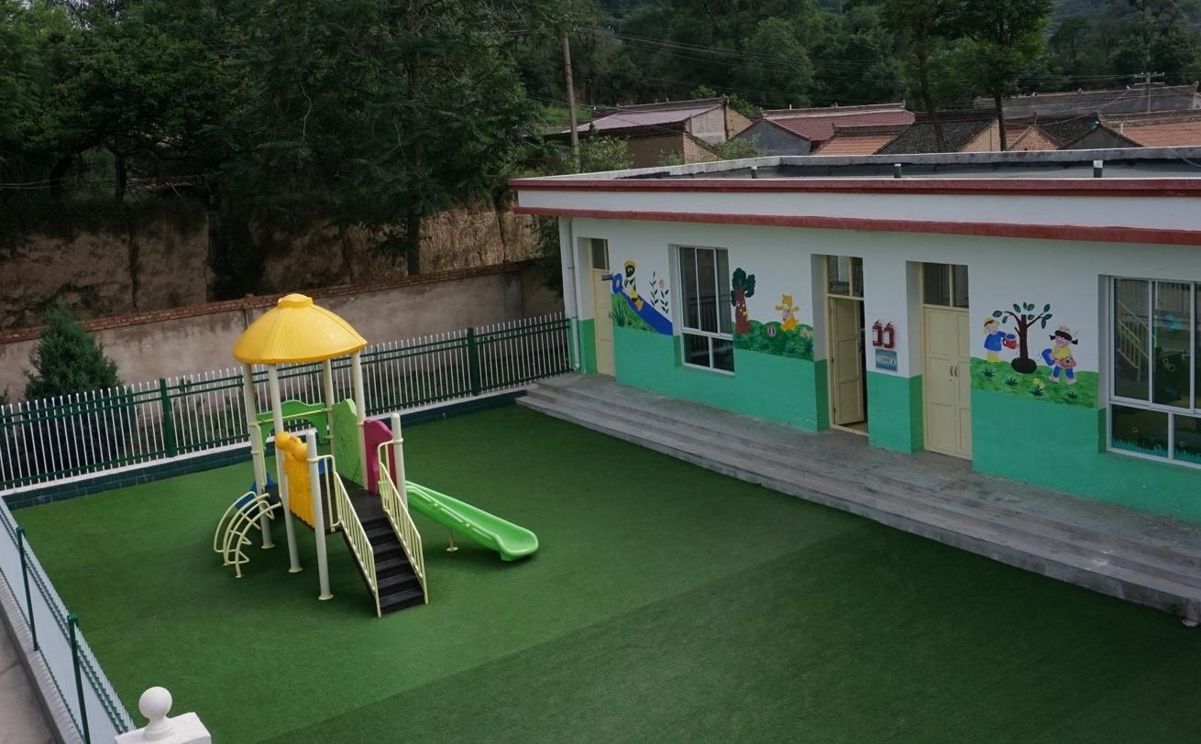

**A Week in 甘肃**

Liang Zhou

What am I doing this summer?

Unclear. It’s most ostensibly a post-college summer trip, and the first real summer vacation I’ve had since middle school. It’s also a reflection on my Chinese heritage, an opportunity to connect with a surprisingly unfamiliar culture. It’s a chance to do all the planning, learning, traveling, almost entirely on my own.

Beyond that, this past week I was given (more accurately, thrown) the opportunity to help out 支教中国 2.0 by visiting three of their partner schools in Gansu on their behalf.

These elementary schools all had dedicated computer classrooms, and my role was to evaluate and help them resolve some of their critical IT issues. Given that an MIT computer science degree in no way prepares you for IT difficulties, I was sent with 张老师, a local teacher skilled in all things IT. The whole venture became both a chance to volunteer and a one-of-a-kind learning opportunity.

China is divided into 23 provinces (along with a host of other non-provincial areas, such as 上海 Shanghai or 新疆 Xinjiang), and each province is again divided into the equivalent of counties (地区, literally *regions*), which are further divided into areas called 县 (*xian*). Our work was entirely centered within Pingliang (平凉) region, in the Huating (华亭), Zhuanglang (庄浪), and Chongxin (崇信) *xian*.

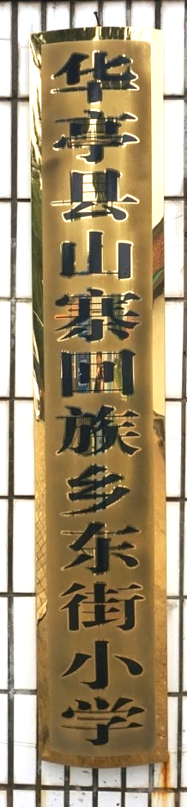 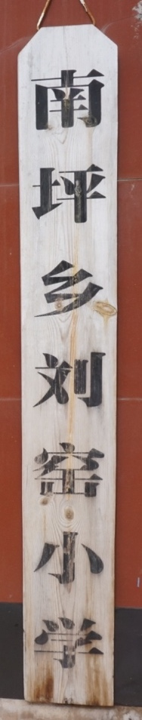 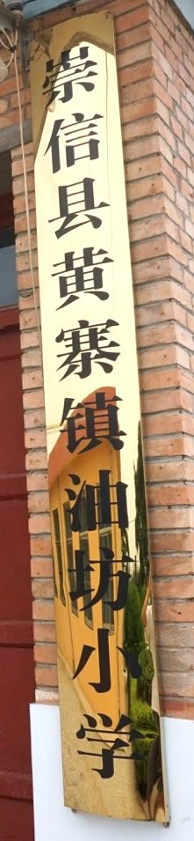

Placards for the schools that we visited!

**7.3 | Tuesday**

It took a whole day to just get from Shanghai to the 平凉 area. I woke up at 5, dragged myself onto the subway, arrived at Shanghai Hongqiao (虹桥) Railway Station, and bought an overpriced breakfast of porridge and a brown rice-youtiao burrito. 张老师 found me, we introduced ourselves, and caught the 7:17 morning train *yawn* for a 7-hour ride to 西安 (Xi’an) at Xi’an North at about 2:30pm. No time to rest: we had to catch a 3:30pm bus from Xi’an bus station, which involved a tight hour’s worth of figuring out the right combination of taking the local metro and walking to the stop. We made it!

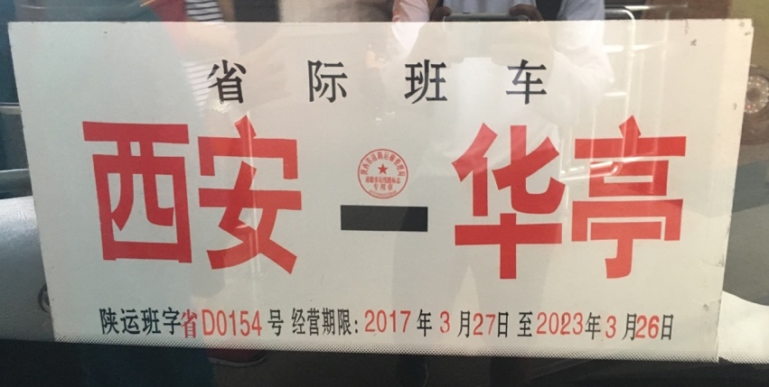

Arrived 5 minutes before it left.

Apparently it was a 7-hour bumpy bus ride…so I’m glad I slept through almost all of it. I woke up groggily to a 10pm arrival in rainy Huating and we quickly found the nearest hotel. Almost all the stores had closed, but we managed to spot a small and remarkably inexpensive dumplings place. My first reaction to the town was overtly negative: I’d given up the comfort, lifestyle, and familiarity for a muggy rainy night in a small town in who-knows-where? Too tired to really think much more and passed out in bed soon after getting back.

**7.4 | Wednesday**

Woke up at 6 for the first day of actual work. Still a bit drizzly outside, but the morning town does have its charms: it’s about as authentically Chinese as you can get, without the tourist traps and with all the morning routines I knew and recognized from when I lived in China almost 20 years ago. We met 张老师 (another one, not the one I was traveling with!) from Dongjie elementary school (东街小学), who took us for a breakfast of lamian (拉面). We caught the 7am bus for a 40-minute ride to a Hui minority (回族) village where the school was actually located and met 李 (Li) 校长 (principal). My first impression was how small the school was: at 66 students and 10 teachers, there was no way they had the resources to effectively teach students at even nearly the same level as in the cities. Over lunch, 李校长 reminisced back when the school had nearly 200 students, but many of the families had moved to the cities in search of better opportunities.

Entering the computer room, it felt almost eerie that this modern technology existed in such large quantities out in the villages where even Internet was sparse – I guess that’s why 2.0 exists! We’d just begun to turn them on and assess the situation when the lights went out.

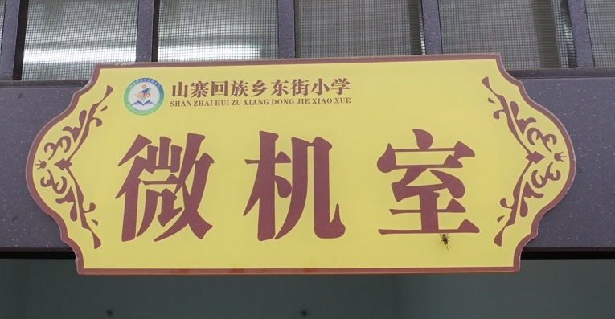

The computer room sign

…so, 张老师 came up with the *brilliant idea* to have me teach an English class.

My Chinese is terrible, their pronunciation is off, I have no idea how to be a teacher, etc. We managed to find some common ground near the end learning translations of different animals.

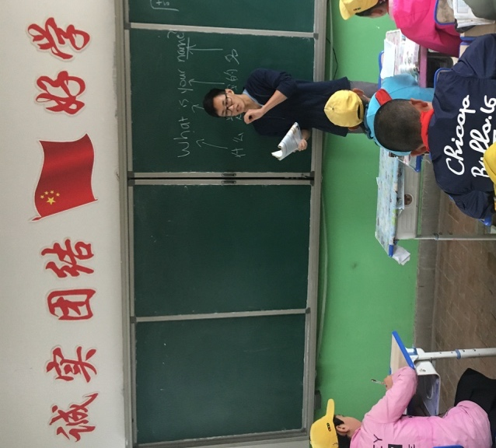

Teaching was stressful but kind of fun. And the kids are cute

The lights came back on, and we set right back to work on the computers. From the very beginning it was clear that the main reason why their computers were slow was the preponderance of attention-grabbing, ad-laden software suffocating the laptops’ CPUs. Students using the computers would unwittingly click on adverts that downloaded and installed software laced with pop-up ads, and the whole cycle would repeat. In fact, it turned out that the original antivirus software was responsible for the ads in the first place.

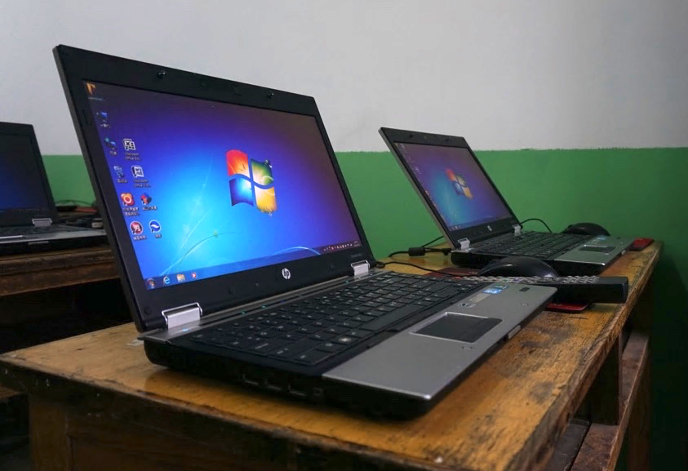

Freshly reset computers in their new state

So, we reset all the computers to a default, unadultered popup-less state. By the time we finished, all the screens looked crisp, clean, and refreshingly ad-free. We headed back to Huating on a 面包车 (because they look like loaves of bread), and had some beer.

**7.5 | Thursday**

Woke up early again to take a 2-hour bus to 庄浪. The most obvious sign that foreigners didn’t come here was the bus station personnel’s near-complete ineptitude at dealing with passports; my guess is that they’d never dealt with one before. On the bus ride 张老师 and I came up with some strategies for more easily tackling the problem we saw with the computers at 东街小学. Also on the bus ride we saw local workers fixing mudslides on the road from the night before.

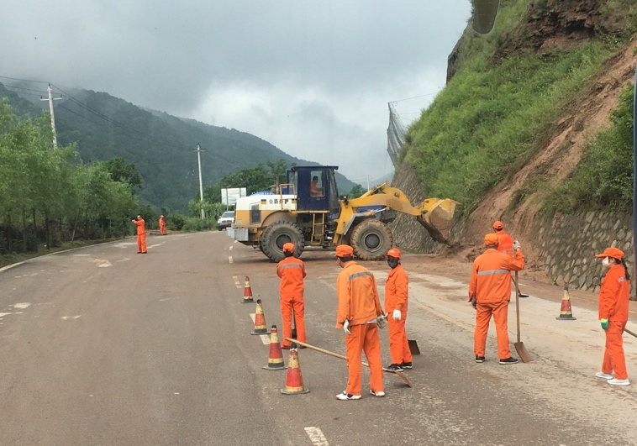

I survived the mudslides!!

陈 (Chen) 校长 picked us up and drove us to Liuyao elementary school (刘窑小学), which was *well-off* enough to have two floors in some of its buildings. The computers in the long-distance classroom were kept in near-pristine condition, wrapped under towels when not in use.

 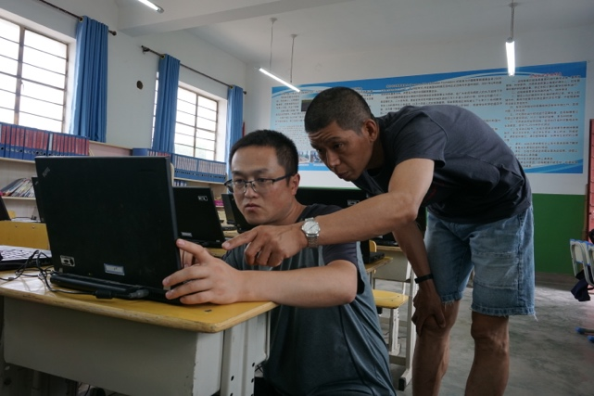

Hard at work fixing and upgrading the laptops in 刘窑小学

In addition to the ads, these computers were also relatively old and slow, so 陈校长 and I upgraded the aging 2G RAM to 8G RAM, which is a lot, for the non-technical crowd out there.

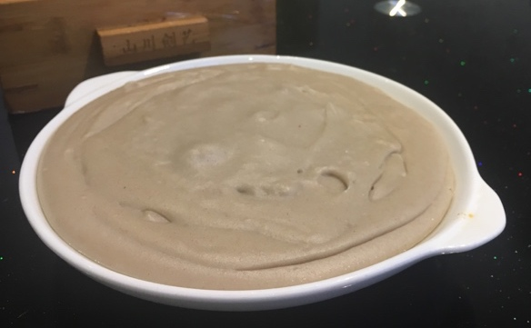

People don’t eat rice here: it’s all noodles. This is pudding made with noodle dough.

**7.6 | Friday**

Finished up the work at 刘窑小学 by late afternoon, and had a delicious dinner of 暖锅 (warm pot?) with 陈校长 and two of the other teachers at the school. What struck us most from the conversation was that even principals such as 陈校长 had never left the 平凉 region, let alone go to Xi’an or Shanghai or any big city. Living in the valleys was insular in itself, simply due to the unnecessariness and expense of even leaving the area. If everything they’ve ever known was confined within those boundaries, what was the point of leaving when life there was content and peaceful enough?

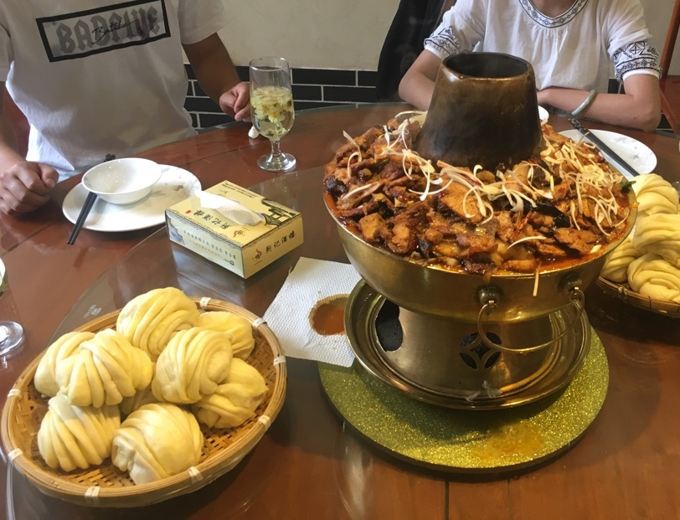

“warm pot”

**7.7 | Saturday**

Woke up at 6 to catch a 7am bus to 崇信 for 3 hours, and were picked up by 于 (Yu) 校长 and had an early lunch of 肉泡馍 (rou pao mo). 崇信 is located in a river valley (as are all the villages, but the valley-ness was especially prominent with 崇信. Youfang elementary school (油坊小学) is located a 15-minute drive away on the northern mountain ridge, with beautiful views all around.



a meal of noodles before climbing 龙泉山

As with 刘窑小学, the students and teachers here took very good care of the computers, but of course the ever-pervasive ads were once again the culprit here. On 于校长’s recommendation, we wrapped up for the day relatively early at 4pm and went on a visit to their local AAAA attraction, Longquan Mountain (龙泉山), which offered absolutely stunning views of the valley below. Just as we reached the peak, the light drizzle turned into rain, and 张老师 and I were chaperoned back to a small local hotel. Down near the bottom of the mountain, the small, newly-constructed old-town tourist village reminded me of Lijiang’s old town, which I’d visited almost a month before. Of the three towns we visited, 崇信 was clearly the most poised for further development.

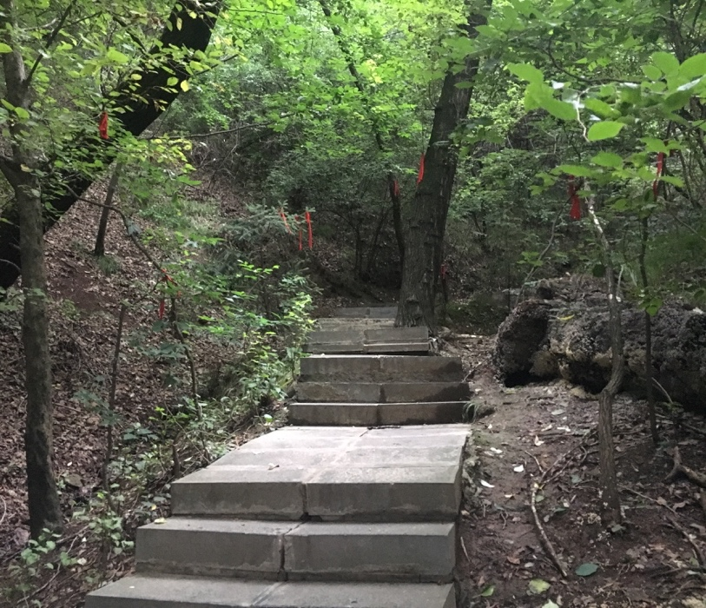 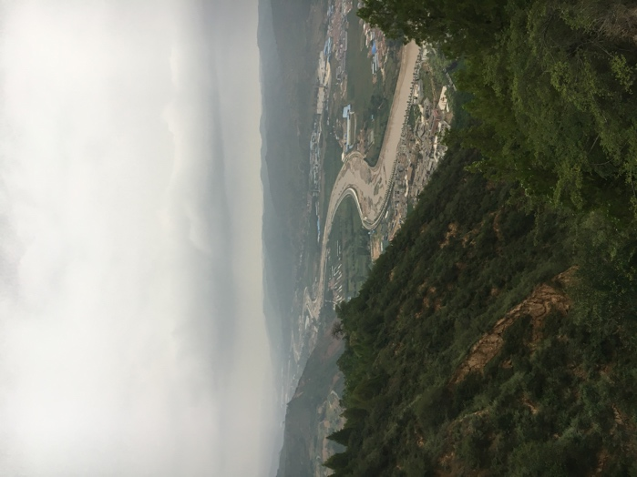

From 龙泉山

**7.8 | Sunday**

Made quick work of the last few computers at 油坊小学 and caught an early 3pm bus back to 西安. No time to eat, but 于校长 bought us snacks for the 5-hour bus ride :)

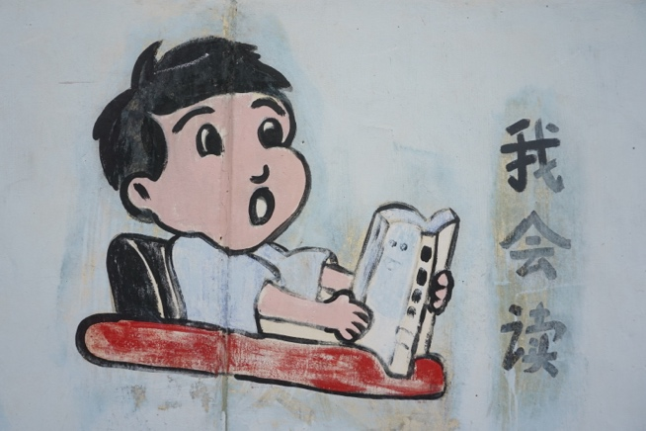 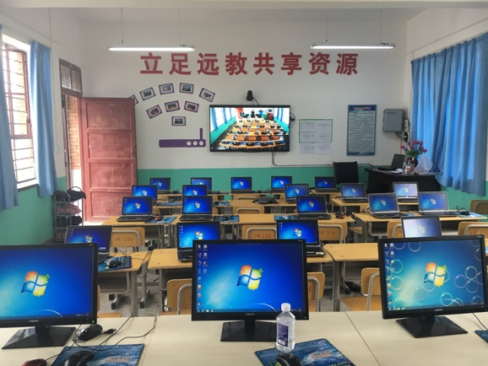

*Left*: I can read. Can you? *Right*: All the computers in 油坊小学 fixed!

**7.9 – 7.10 | Monday – Tuesday**

2-day Xi’an city trip! Brief itinerary (e.g. list of places visited): Xi’an Museum (西安博物院), walked all 8.6 miles (13.7km) of Xi’an city wall (西安城墙), Shaanxi History Museum (陕西历史博物馆), Banpo Museum (半坡博物馆), Muslim Quarter (回民街), Xi’an Great Mosque (清真大寺), Mobike/Ofoing around the city

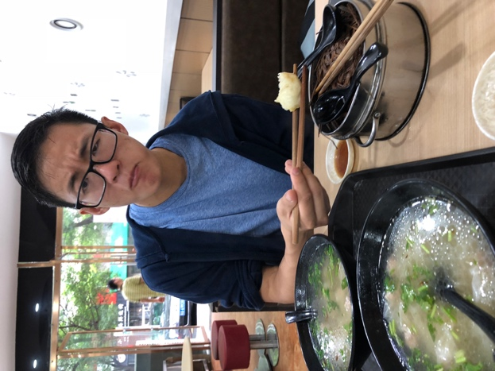 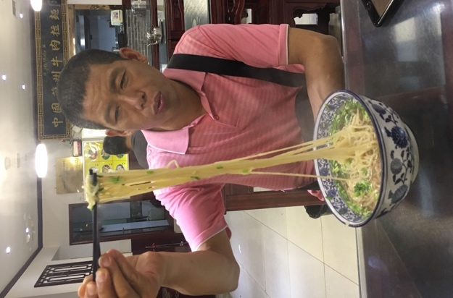

We love food

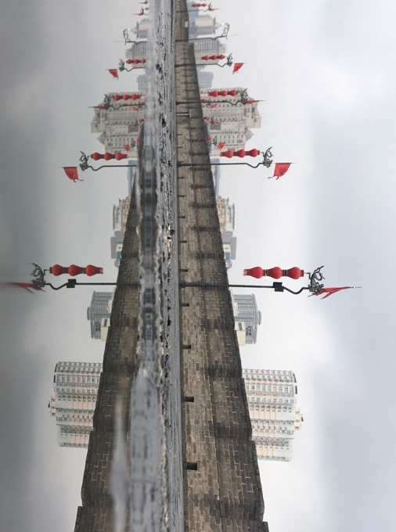

The Xi’an city wall after rain. More rain to come

**7.11 | Wednesday**

Early 9:23 train back to Shanghai. No rain in Shanghai but humidity is off the charts.

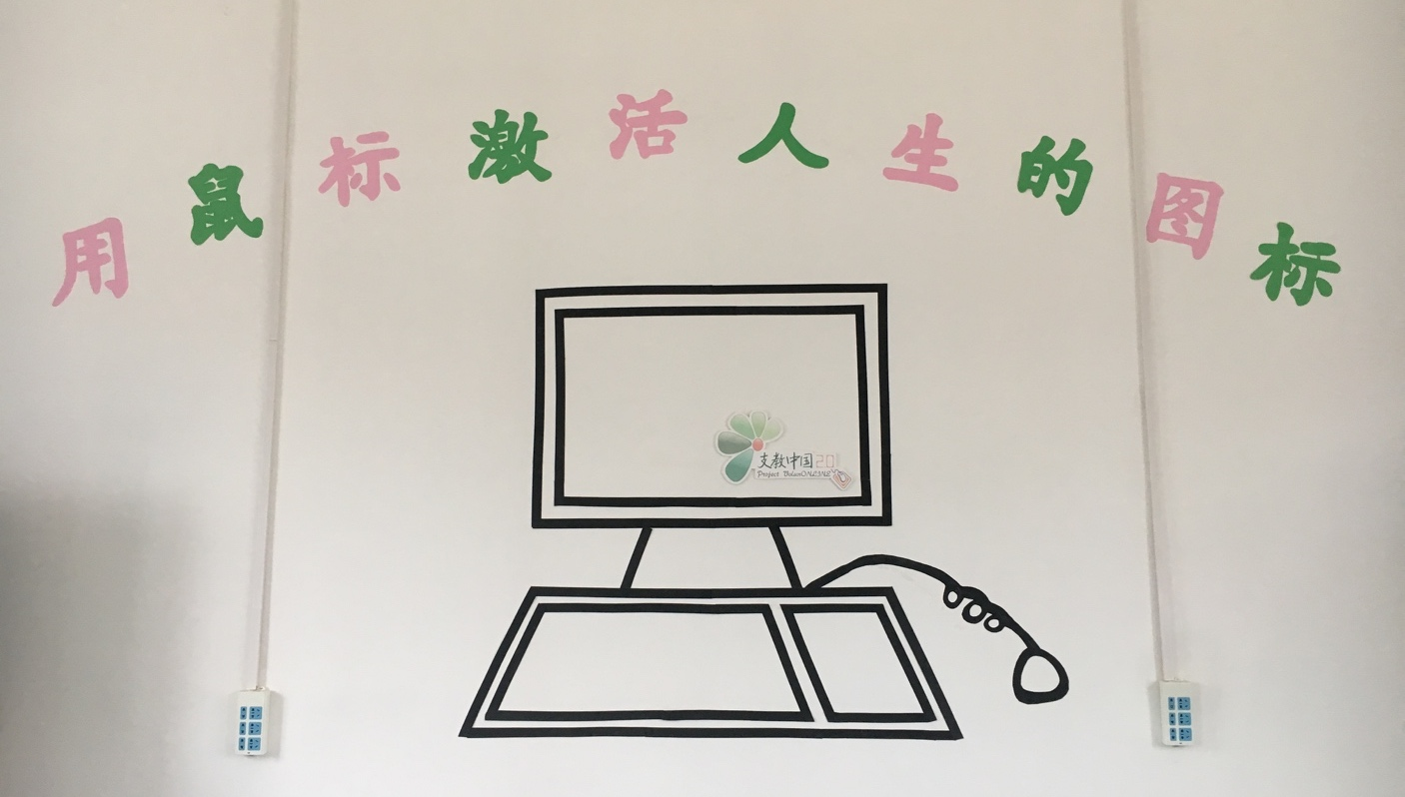

**About the author**



周亮是在美国出生长大的；他刚刚毕业大学。这夏天，他决定和2.0做个志愿者，也想多了解中国乡村里的教育条件。回美国以后，他打算去英国留学读硕士。